The first step in accessing your license information starts at our website, or “portal”. The url address for the portal is https://elicense.az.gov.
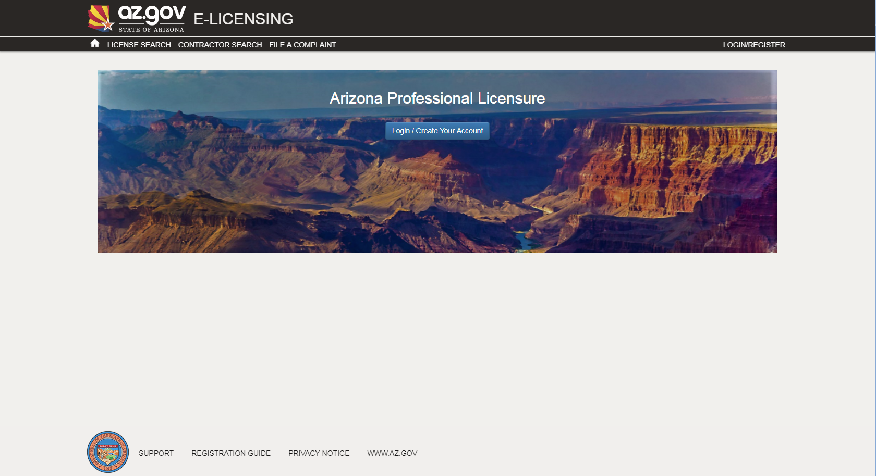

Once you see the screen above, use your mouse to click on the “Login/Create Your Account” button.
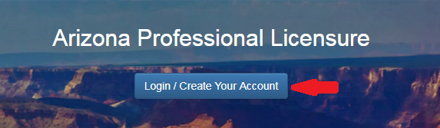

You are now on the eLicensing Login screen. Since you already have a license but have not created your login yet, you’ll click on the “I Have a License” button.
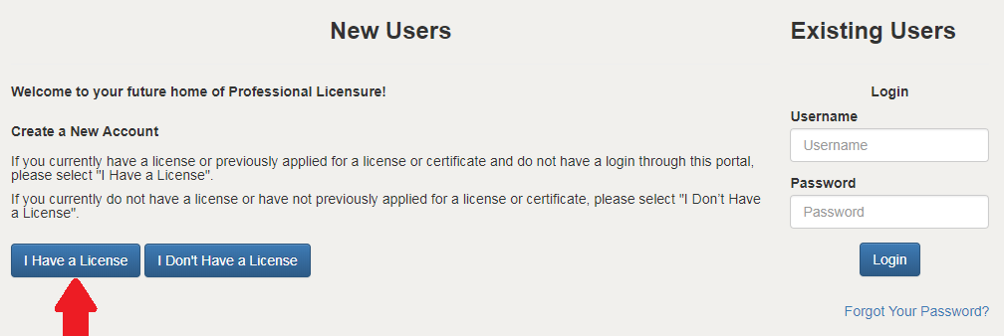
You should now be at the Self Registration screen.

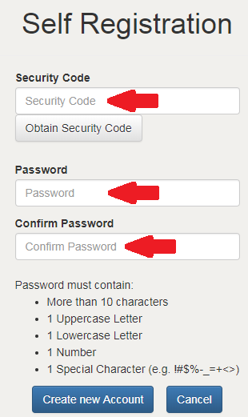
The first field you need to enter is the Security Code. This code was sent to you either in an email or a letter.
Enter your security code in the security code field.
Then create your password by entering it in the Password and Confirm Password boxes.
Be sure to use more than 10 characters, 1 uppercase letter, 1 lowercase letter, 1 number and one special character.
When you’ve complete your entry, click on Create new Account.

The next time you log onto our eLicensing portal, your username will be the email address we have on record. Please see the instruction for changing your personal information (below) to update it, if needed.

Your “Dashboard” screen should appear. On this screen, you should see your license (white box with your license number in it).
If your license is eligible for renewal, the word “Renew” will appear. The word “Renew” will not appear until the license is eligible for renewal. You may contact your licensing Board for when renewal eligibility is activated.
You can see the status of your license(s) and application(s) from the Dashboard.

You can also change your personal information (including your email address, physical addresses and phone numbers) from this screen. Just click on “Edit Profile”.

