The first step in accessing your businesses information starts at our website, or “portal”. The url address for the portal is https://elicense.az.gov.
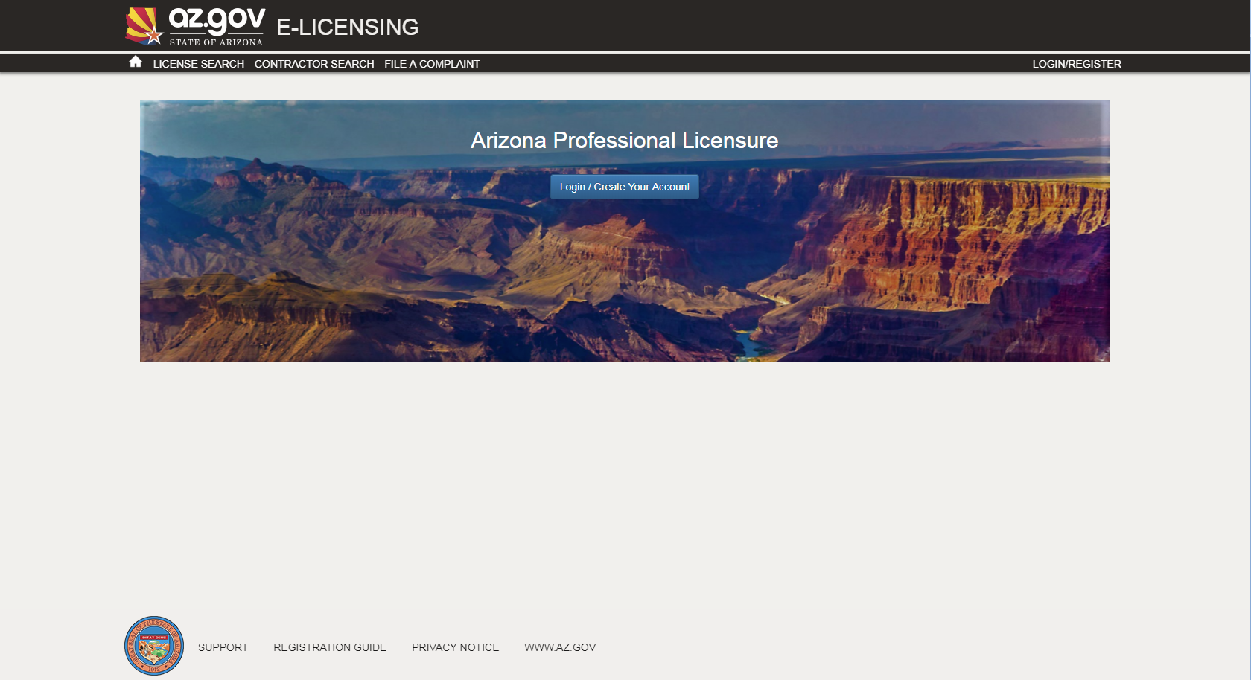

Once you see the screen above, use your mouse to click on the “Login/Create Your Account” button.

You are now on the eLicensing Login screen. Since you already have a license but have not created your login yet, you’ll click on the “I Have a License” button.
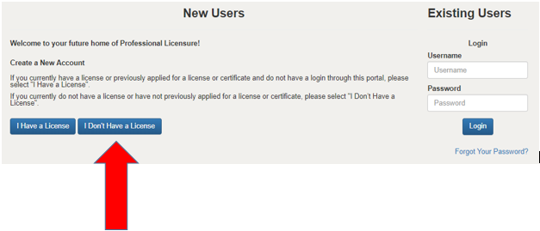
You should now be at the Self Registration screen.
The first field you need to enter is the Security Code. This code was sent to you either in an email or a letter.
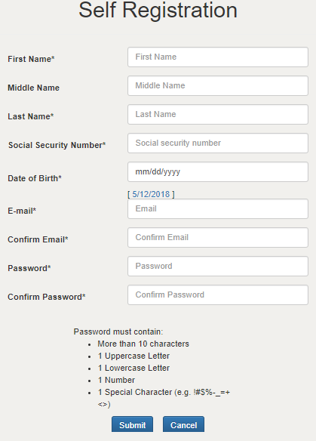
Enter your security code in the security code field.
Then create your password by entering it in the Password and Confirm Password boxes.
Be sure to use more than 10 characters, 1 uppercase letter, 1 lowercase letter, 1 number and one special character.
When you’ve complete your entry, click on Submit.
The next time you log onto our eLicensing portal, your username will be the email address we have on record. Please see the instruction for changing your personal information (below) to update it, if needed.

Your “Dashboard” screen should appear. On this screen, you should see your license. You can now link yourself to a business. Click “Manage Businesses”.
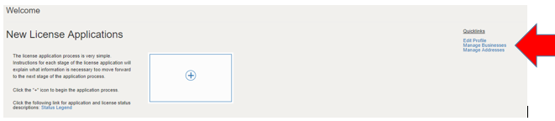
If you are connecting to a business already licensed with your Board you select “Add existing business”. If you need to add a new business so you can apply for a license on behalf of the business you select “Add new business”.
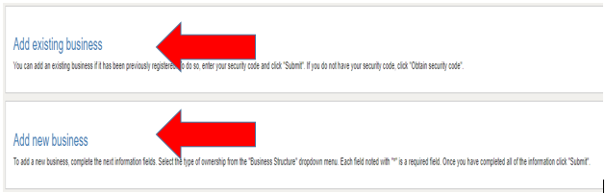
“Add existing business”
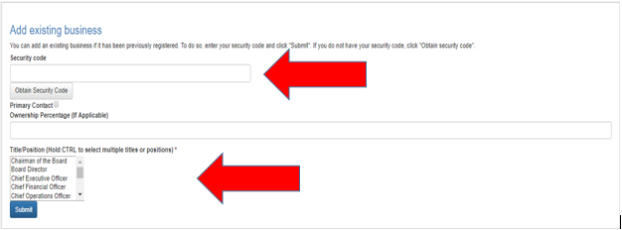
In order to add and existing business, you will need the businesses “Security code”. Enter the required information and click “Submit”. You should see a note similar to the one below indicating a successful link.
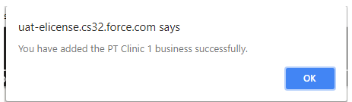
Once you complete the above step you can begin adding other person(s) to the business.
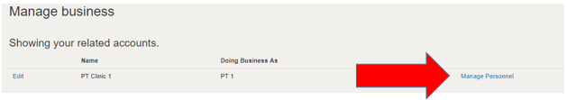
Enter the information as indicated on the screen.
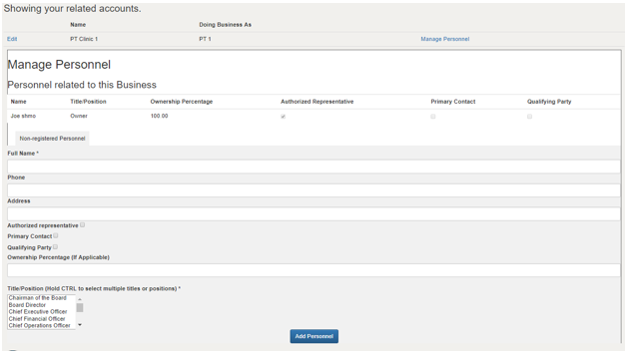

“Add new business”
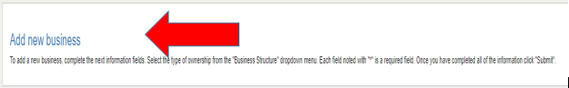
Click on “Add new business”
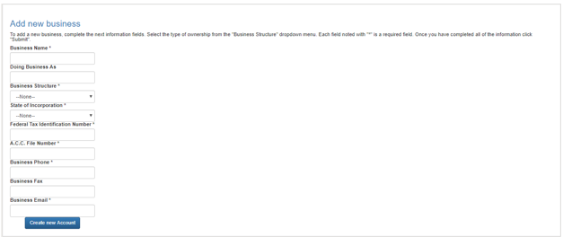
Complete the required fields indicated by the “*”.
Click “Create new Account”.
You will see a warning.
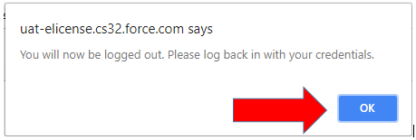
Click OK.
You will now return to the main Portal page.

Click on the Login button and login again. You can then see your added business by selecting “Manage Businesses”.
