The first step in beginning your application process starts at our website, or “portal”. The url address for the portal is https://elicense.az.gov.
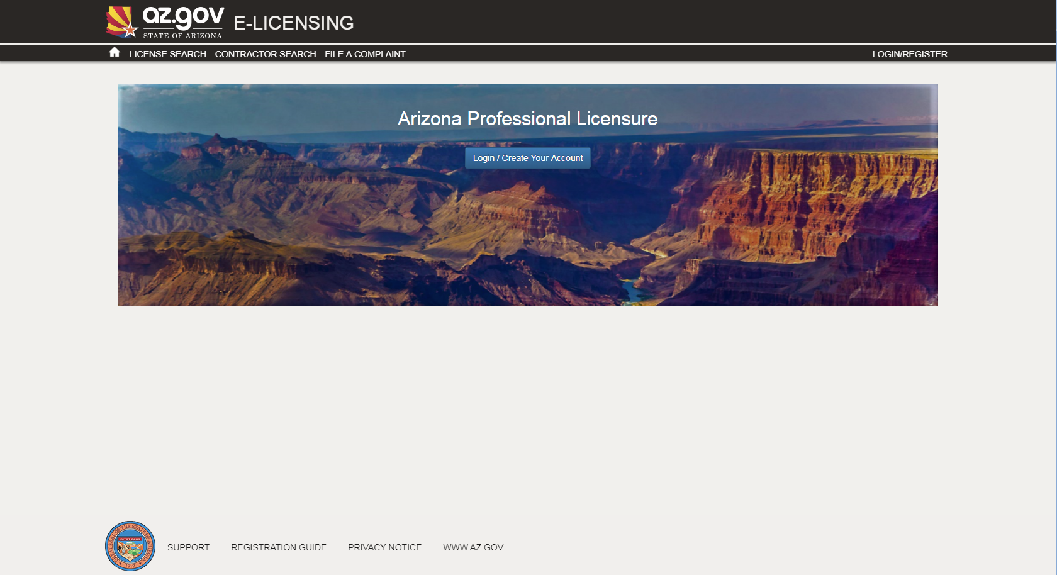

Once you see the screen above, use your mouse to click on the “Login/Create Your Account” button.

You are now on the eLicensing Login screen. Since you already have a license but have not created your login yet, you’ll click on the “I Don’t Have a License” button.
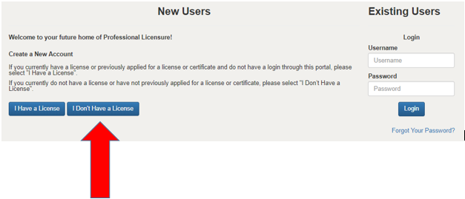
You should now be at the Self Registration screen.
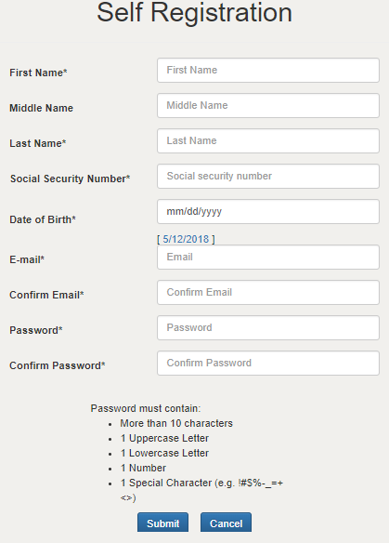
You must complete all items marked with an “*”.
When you’ve complete your entry, click on “Submit”.
The next time you log onto our eLicensing portal, your username will be the email address we have on record. Please see the instruction for changing your personal information (below) to update it, if needed.
Your “Dashboard” screen should now appear. On this screen, you can apply for licenses, update your information and make service requests.You can change your personal information (including your email address, physical addresses and phone numbers) from this screen. Just click on “Edit Profile”.
You can see the status of your license(s) and application(s) from the Dashboard. If your license is eligible for renewal, the word “Renew” will appear. The word “Renew” will not appear until the license is eligible for renewal. You may contact your licensing Board for when renewal eligibility is activated.

